**PROJECT 1:**

**Deploying a web server in Windows instance**

**Task 1:Create a windows instance using AMI :Windows 2012 R2 base**

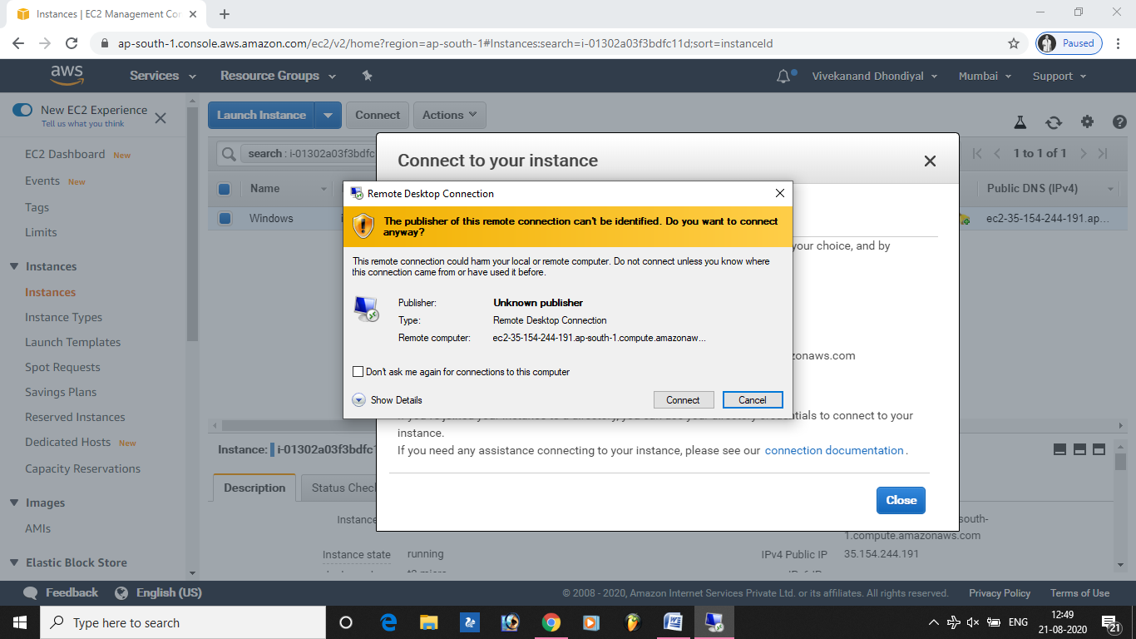

**Task 2:Launch the Windows instance using RDP**

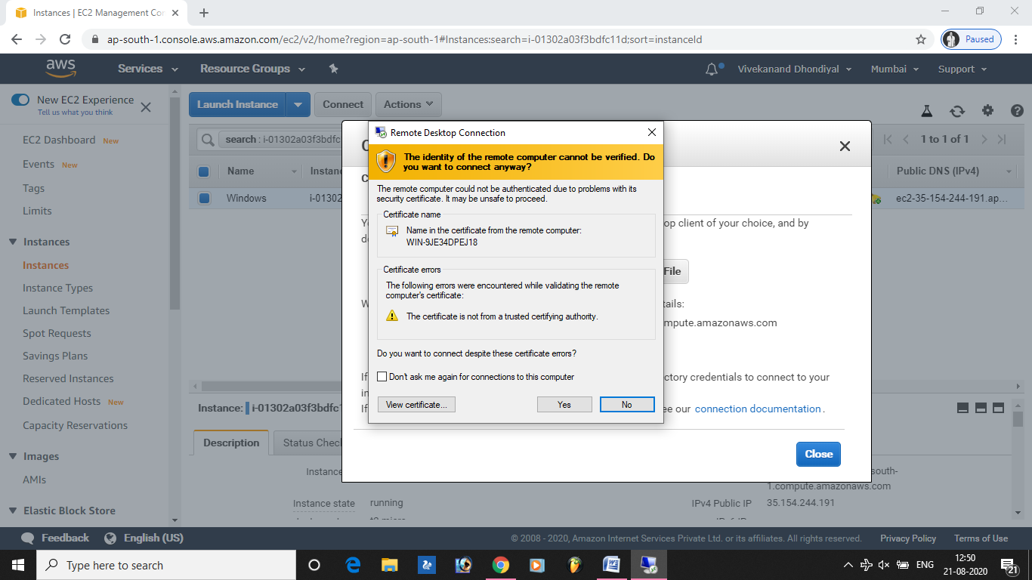

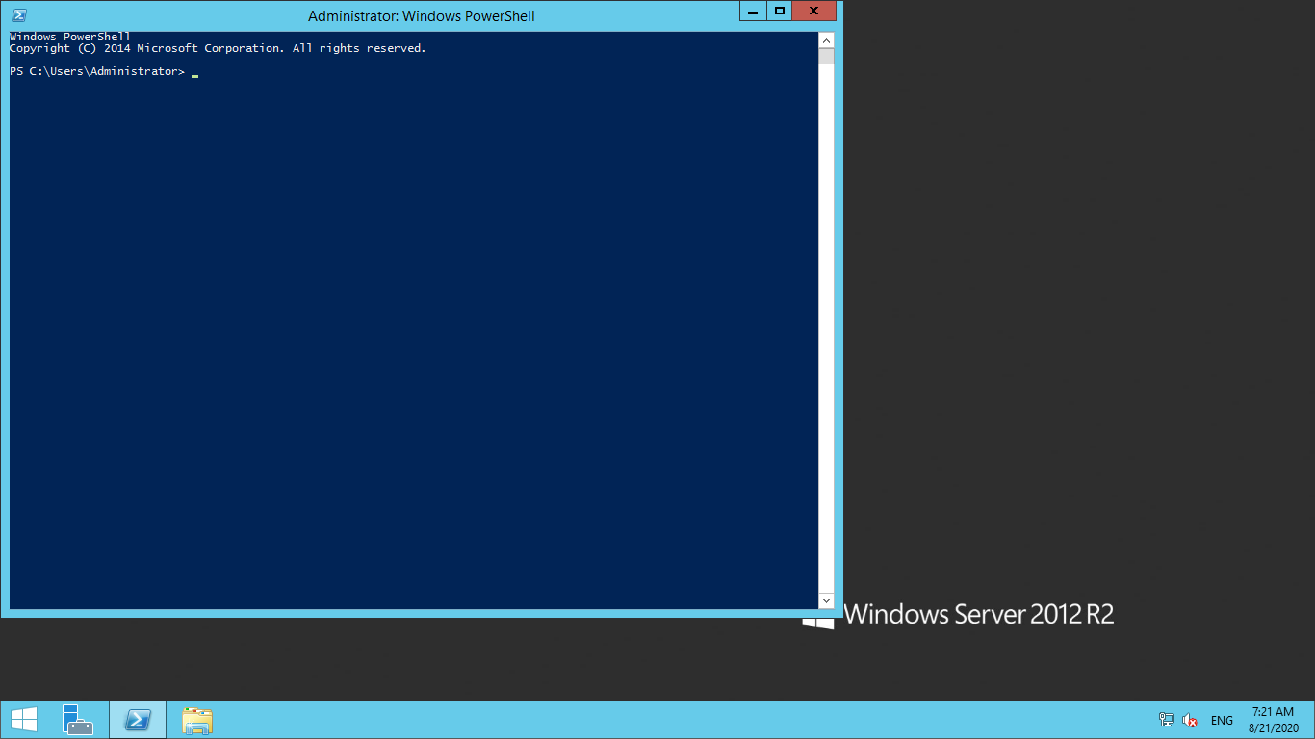

**Task 3:Install IIS web server using Powershell ISE**

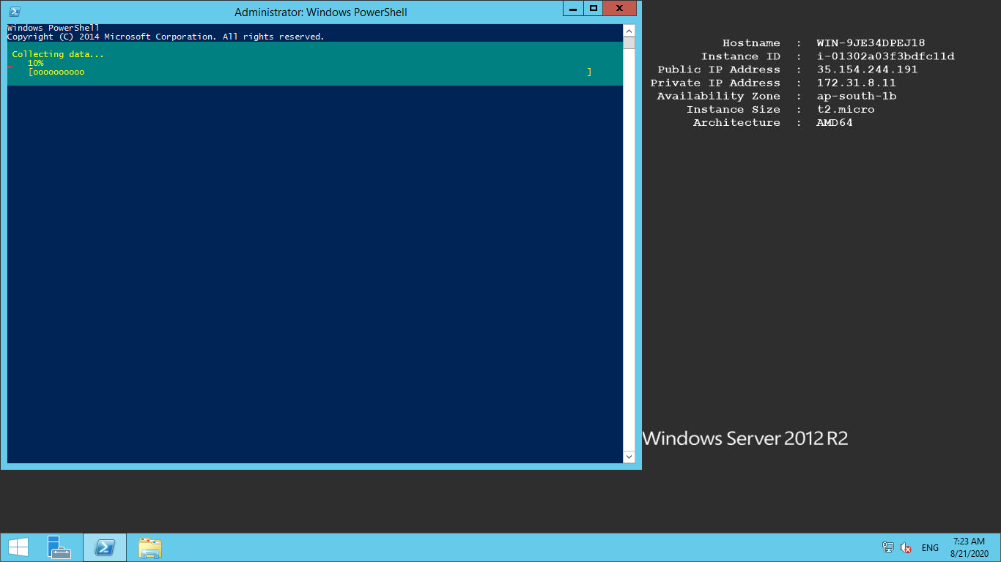

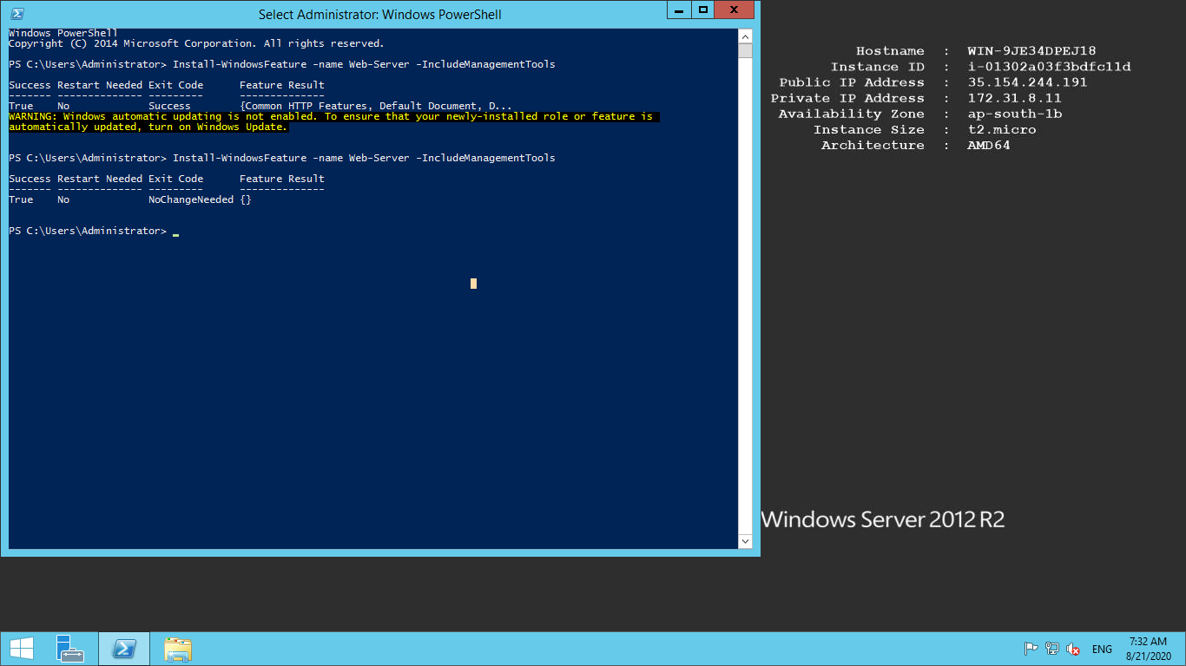

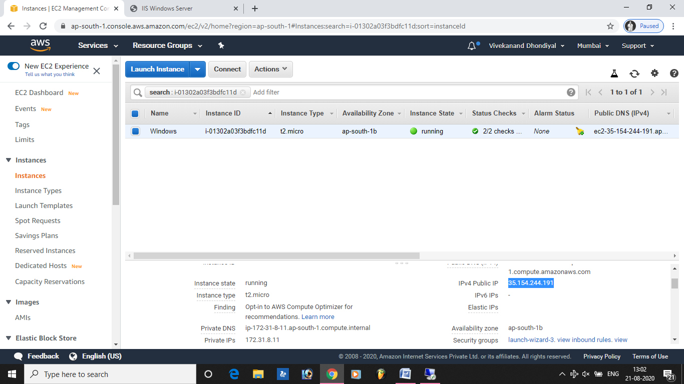

**Task 4:Verify successful installation of IIS Web Server**

